Atharv Arya

1BM18CS020

PROGRAM TITLE: DISTANCE MEASURING

Aim: DESIGN A SYSTEM TO MEASURE THE DISTANCE BETWEEN OBJECTS

Hardware Required:

* Arduino Board
* Ultrasonic Sensor

Circuit Diagram:

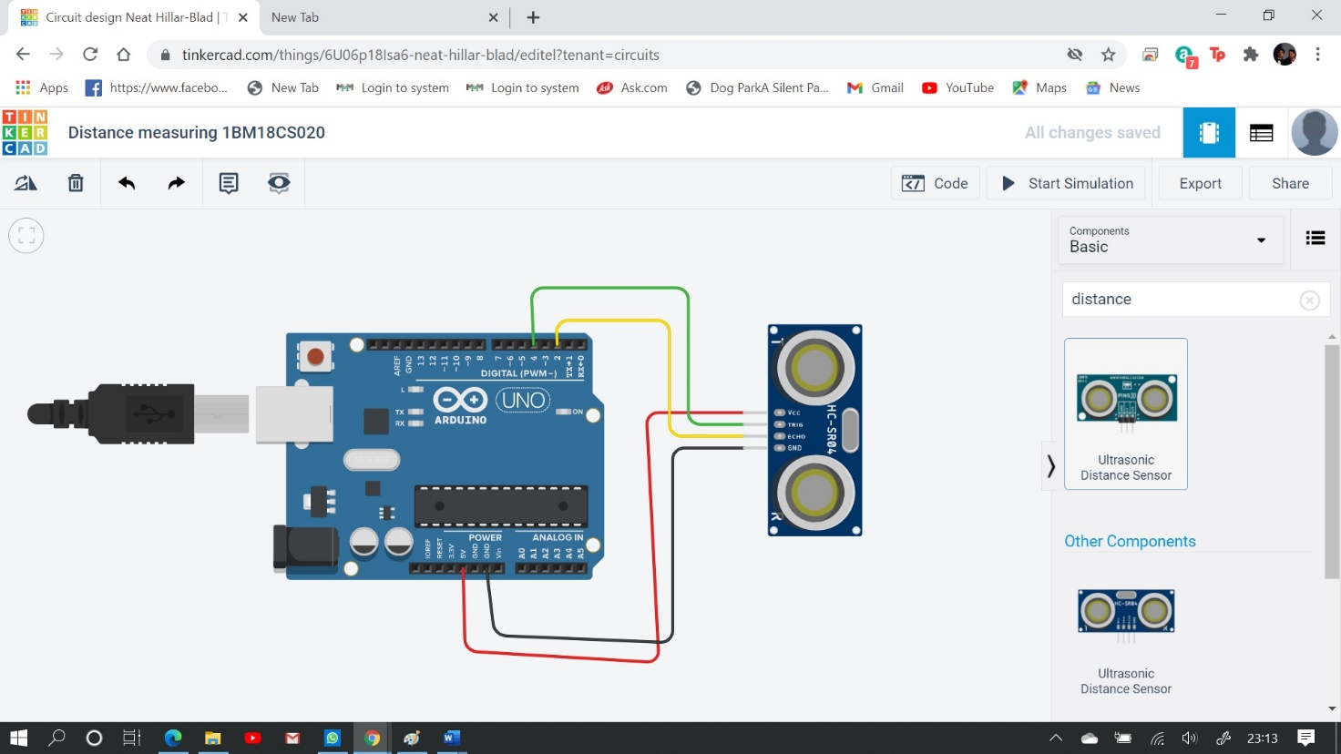

Write-Up:

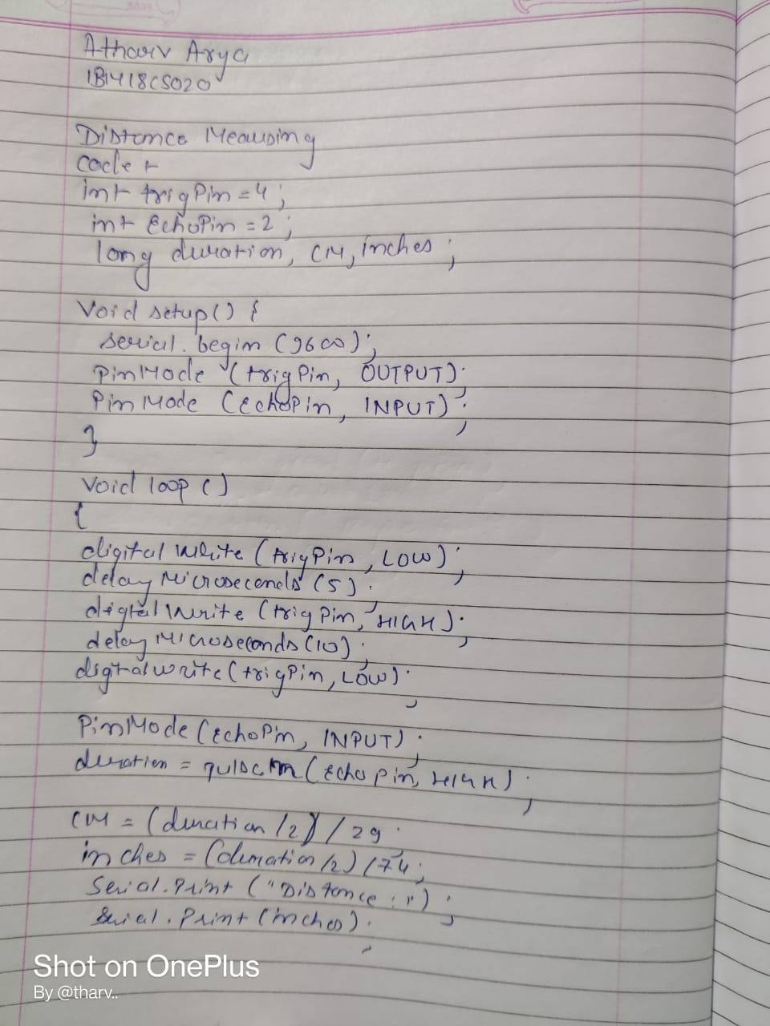

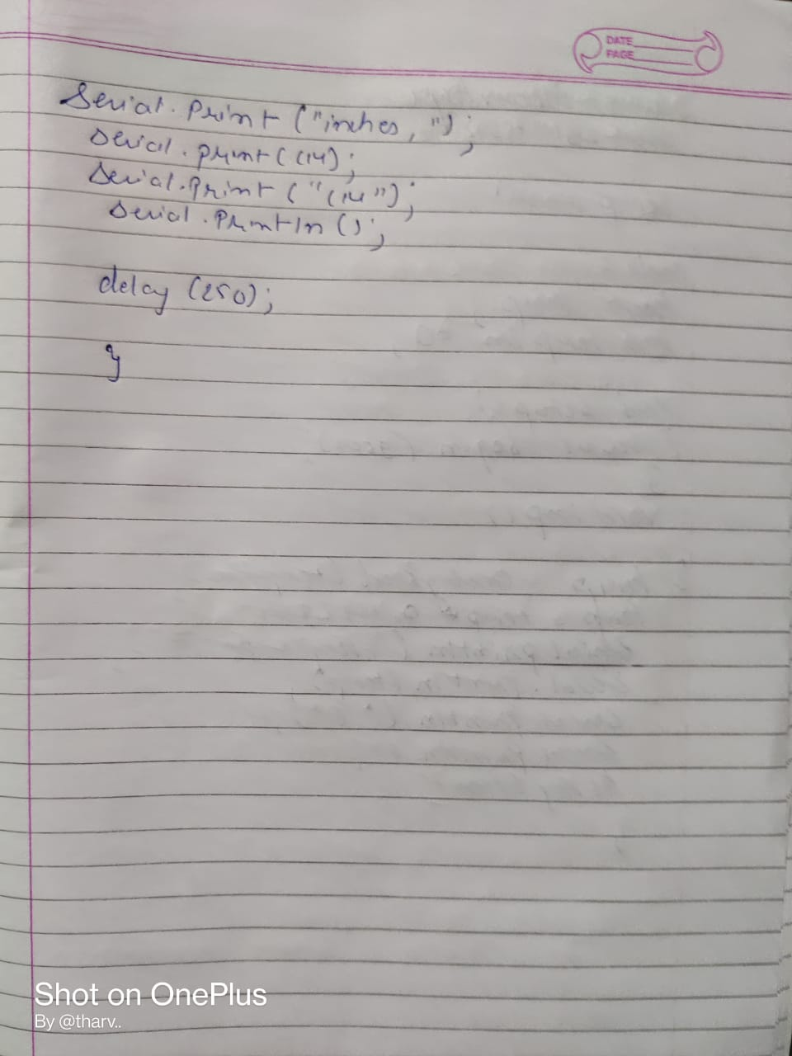

CODE:

int trigPin = 4; int echoPin = 2;

long duration, cm, inches;

void setup() { Serial.begin (9600);

pinMode(trigPin, OUTPUT); pinMode(echoPin, INPUT);

}

void loop()

{

digitalWrite(trigPin, LOW); delayMicroseconds(5); digitalWrite(trigPin, HIGH); delayMicroseconds(10); digitalWrite(trigPin, LOW);

pinMode(echoPin, INPUT); duration = pulseIn(echoPin, HIGH);

cm = (duration/2) / 29;

inches = (duration/2) / 74; Serial.print("Distance: "); Serial.print(inches); Serial.print("inches, "); Serial.print(cm); Serial.print("cm"); Serial.println();

delay(250);

}

OUTPUT/OBSERVATION:

The distance is being measured.